“Heaven’s light is our guide”

**Rajshahi University of Engineering & Technology**

Department of

Computer Science & Engineering

**Course No: CSE 3110**

**Course Title: Microprocessors and Assembly Language Sessional**

**Lab Report (Lab 2)**

|  |  |
| --- | --- |
| Submitted By:  ***Saifur Rahman***  *Roll No:* ***1703018***  *Section: ’17-A*  *Class: 3rd year (Odd Semester)* | Submitted To:  ***Sadia Zaman Mishu***  *Assistant Professor,*  *Dept. of CSE,*  *RUET.* |

***Date of Experiment: 26thJanuary, 2021***

***Date of Submission: 2nd February, 2021***

Experiment no: 01

Name of the experiment:

**Write an assembly language program to read one of the hex digits (A-F) and display it on next line in decimal.**

Objectives:

Writing an assembly program to

* Prompt the user for a character input
* Convert it to decimal
* Display the output

Code:

1. .MODEL **SMALL**
2. .**STACK** 100H
4. **.DATA**
5. **CR EQU 0DH**
6. LF **EQU** 0AH
7. MSG1 **DB** 'Enter a hex digit: $'
8. MSG2 **DB** 0DH, 0AH, 'In decimal it is: $'

11. .**CODE**
12. MAIN PROC
14. *;initialize DS*
15. **MOV AX, @DATA *;get data segment***
16. **MOV** **DS**, **AX** *;initialize DS*
18. *;print user prompt*
19. **LEA** **DX**, MSG1 *;get first message*
20. **MOV AH, 9 *;display string function***
21. **INT** 21H *;display string*
23. *;take input*
24. **MOV** **AH**, 1 *;read character function*
25. **INT 21H *;read character***
26. **MOV** **BL**, **AL** *;store character's ASCII value*
27. **SUB** **BL**, 17D *;subtract 17 to match the ASCII value*
28. *;with 0 - 5 of decimal digit*
29. *;print it*
30. **LEA DX, MSG2 *;get second message***
31. **MOV** **AH**, 9 *;display string function*
32. **INT** 21H *;display string*
34. **MOV** **DL**, 49D *;display 1 at the first*
35. **MOV AH, 2 *;display character function***
36. **INT** 21H *;display character*
38. **MOV** **DL**, **BL** *;display the stored character*
39. **MOV** **AH**, 2 *;display character function*
40. **INT 21H *;display character***
42. *;DOS exit*
43. **MOV** **AH**, 4CH
44. **INT** 21H
46. MAIN ENDP
47. END MAIN

Output:

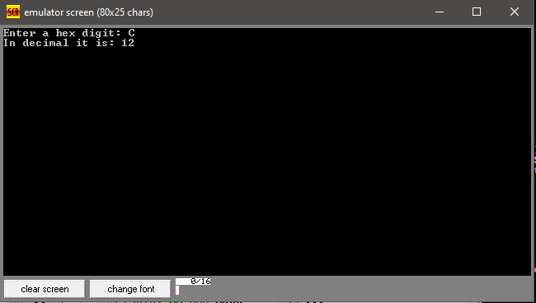

Discussion:

To convert a hex digit, at first the input is taken as a character. Then its ASCII value is stored. The ASCII value of A-F is just 17 value forward from 0-5, In decimal these values are 10-15. So, to show the output an extra ‘1’ (decimal value 49) needs to be shown at first then the subtraction value of characters ASCII value and 17.